**Student Guide for Sitting Final Assessment (Computing)**

Please read all the details below carefully.

**General Exam Details:**

1. Your final assessment will be conducted in 2-3 sessions. Each section will have 40-60 minutes of writing time plus 10-15 minutes of answer compilation and upload time.
2. Your final assessment questions will be posted in the Canvas subject’s quiz section.
3. Your lecturer will give you clear instruction in each final assessment session on whether you need to write the answers directly in the quiz’s essay question writing space or allow you to do file upload. Please follow the instruction strictly.

**During Exam:**

1. You are required to login to Canvas Conference or Teams meeting session which is set up by your lecturer at least 5 minutes before the final assessment time.
2. You are required to open the webcam and show your full face clearly throughout the final assessment duration. If you do not have webcam, please use your phone to login to Canvas and Teams accordingly. This requirement is compulsory.
3. In addition, you are required to record your screen movement with screen capture software for the entire final assessment duration. You are only allowed to open Canvas/Teams screen and any file conversion websites if so required.
4. Once the assessment time is over, you are given 1-hour time to save your video and upload to the designated Google Drive or OneDrive which is prepared by your lecturer. For morning session, upload by 1pm. For afternoon session, upload by 6pm. This requirement is compulsory.
5. A guideline to do screen recording and video file preparation is given at the end of this guide. You can use the suggested software Flashback Express or any suitable screen recording software.
6. If you are using file upload for your answer, please make sure that you give high resolution image/PDF file.
7. Please check whether you have uploaded the correct file before you clicked the submit button. Request to re-upload file due to wrong attachment will not be entertained.
8. Since each assessment session is no longer than 1-hour, NO toilet break is allowed. You are required to sit in front of your webcam in entire assessment time.

**Reminder:**

1. This is a **closed-book assessment**. You are not allowed to refer to any sources during this assessment. Once you start taking the assessment, you are not allowed to communicate with anyone through any means.
2. Your submission work is subjected to Turnitin checking. If it is found that your work is high similarity with any online sources, you may be required to attend a dishonesty hearing to explain your work.
3. Students caught copying, plagiarising or engaging in any form of action with the intention to cheat (include hiring third party to do test for you) will be penalized.

**Absent Rule:**

1. Absent with the reason of no Internet connectivity is not accepted. You are responsible to make sure that you have good and stable Internet connectivity which allows you to do webcam video streaming and file upload during entire assessment.
2. Students must report any extenuating circumstances (such as ill-health or bereavement) which cause you unable to sit for the online assessment. You are required to report the circumstances to Head of Department Dr. Lim Chia Yean via email chiayean.lim@kdupg.edu.my within 48 hours of your final assessment time. Late appeal will not be entertained and you will be treated as absent for exam.

* Reports of illness must be supported by medical certificates together with duly completed medical attestation forms.
* Medical certificates together with medical attestation forms are acceptable if they:
  + Are signed by a medical practitioner.
  + Indicate the date(s) when the student was ill.
  + Provide sufficient detail (without breaching confidentiality) about the illness.
* Non-medical circumstances (e.g. bereavement) should be reported in writing, with a description of the circumstances and when they occurred.

1. Extenuating circumstances for appeal to sit for Referral Exam will be tabled to University College Assessment Board for approval.
2. If you are late to attend the online assessment, no extra time will be given. The quiz portal will automatically close after assessment time is over.

See next page on guide for recording and saving screen capture video.

**Steps for recording screen capture video:**

Step 1:

Go to this website <https://www.flashbackrecorder.com/express/> and choose SCREEN RECORDER FlashBack Express for free.

Step 2:

Launch the installer and install the software in your desktop/laptop.

Step 3:

Look for Flashback Recorder Express and launch it to start your recording.

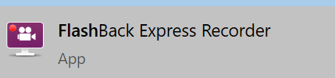

Step 4:

On the setting for Microphone and PC Sounds. Click record when assessment starts.

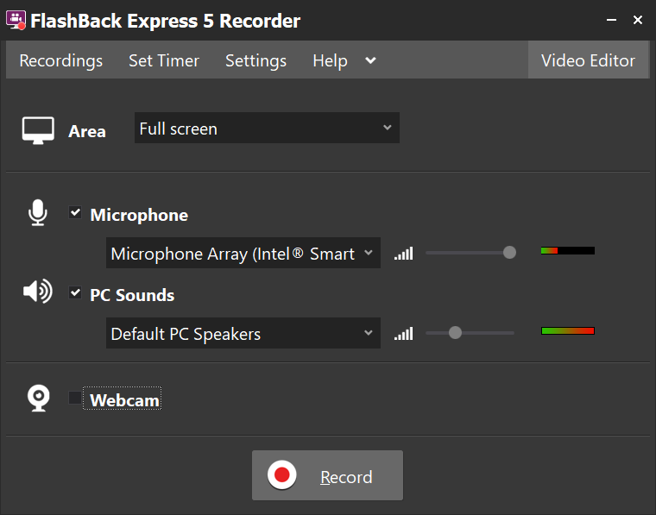

Step 5:

Stop the recording when times up.

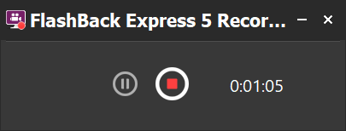

Step 6:

Click Save. Save your file in the file name of <subject code>_<part 1/2>_<your student id>.

Ex: CBC3023_part 1_019111

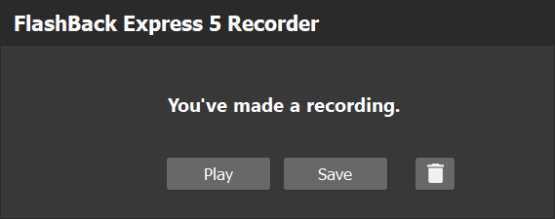

Step 7:

Open the file which you saved in the directory with Flashback Express 5 Player. Choose “Export”.

(note: webcam screen is not required)

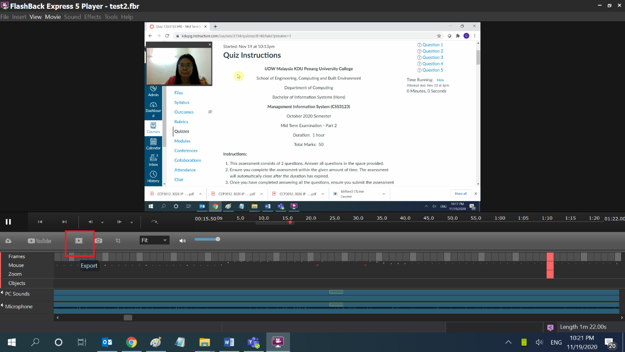

Step 8:

Save as “MPEG4”.

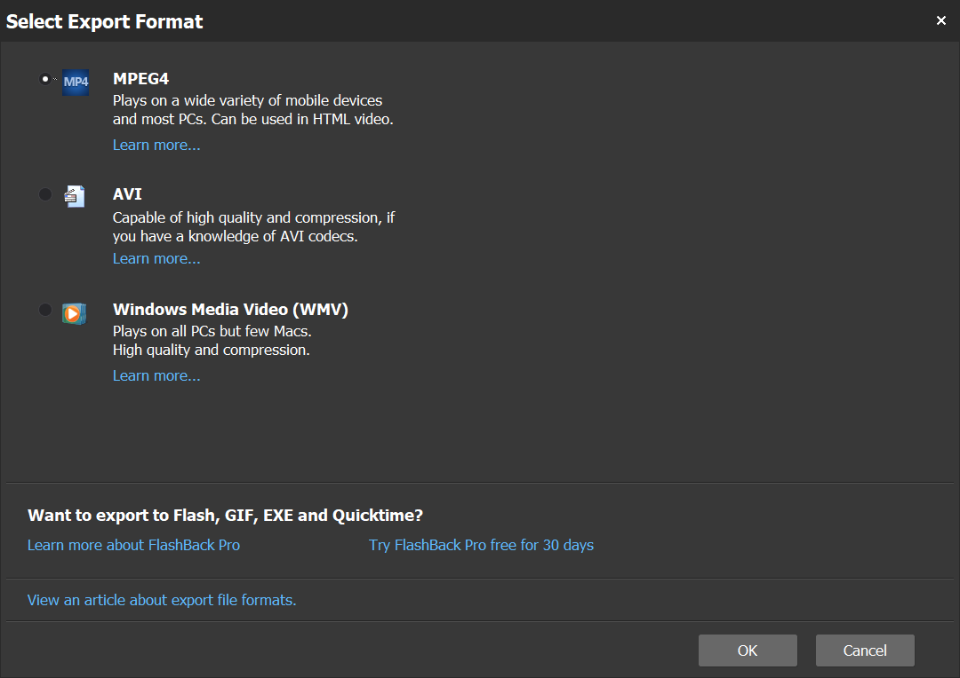

No need to change anything here and just click export.

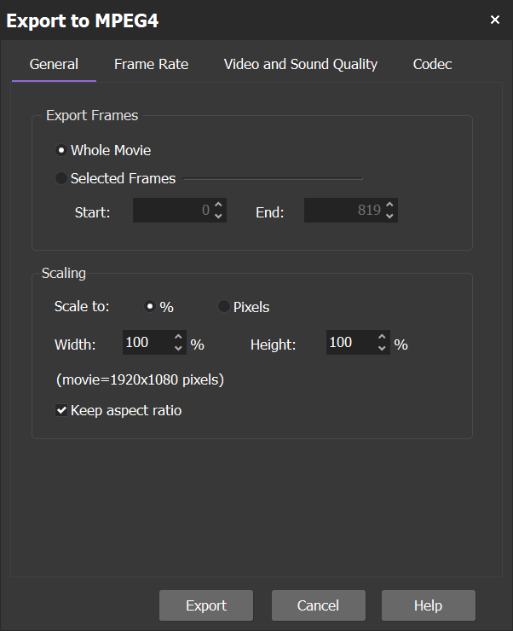

Step 9:

Choose a location you want to save it.

Step 10:

Once the export is done, you can copy the file from your file directory to online Google Drive or OneDrive for submission.